‘The Magic of Wonderland’
Alice tumbles into Wonderland and ‘pops-up’ in Denbighshire Schools

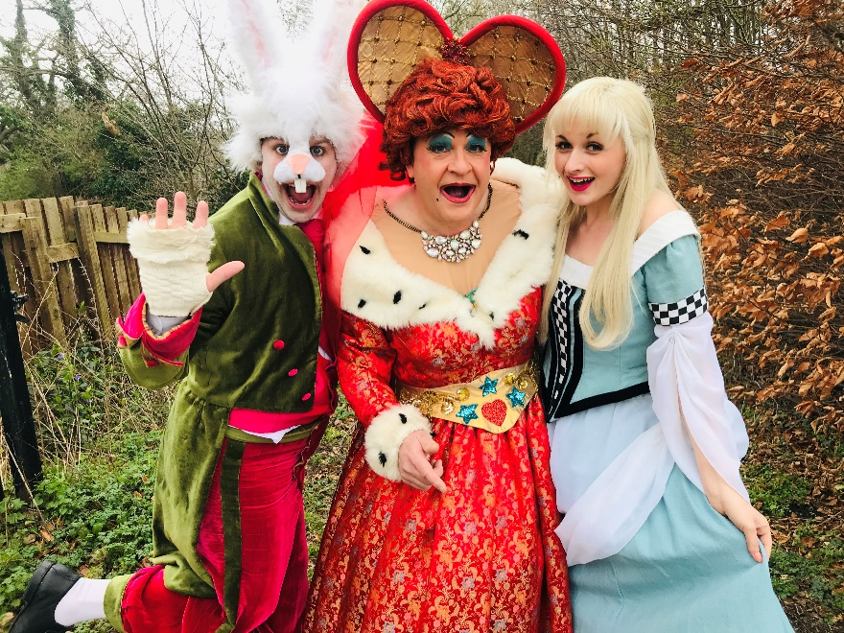

Throughout May and June 2019, fifteen Denbighshire schools, all part of this year’s Enrichfest 2019, Denbighshire’s Curriculum Enrichment initiative, will join Magic Light Productions down the Rabbit-Hole, as they present their riotously entertaining puppetry version of Lewis Carroll’s most celebrated work in a ground-breaking ‘pop-up’ theatrical performance of ‘The Magic of Wonderland’, plus puppetry workshops, in Denbighshire schools.

Packed to the rafters with colourful characters in costume, magic and a dazzling array of beautifully constructed puppets, the pop-up production even incorporates Denbighshire school children’s very own prize-winning designs, drawn from entries in this year’s series of Cheshire Cat Challenge competitions. This much-loved timeless tale comes to life on stage as Alice, one of literature’s most beloved heroines, embarks on a madcap adventure through the peculiar world that is Wonderland.

Using clever stagecraft and limitless possibilities of imagination, this unique ‘pop-up’ stage production, designed for schools, has been written and directed by Magic Light Productions, a North Wales based theatrical production company, producing pantomimes, theatre shows and events across the UK and features the main characters from the book. The White Rabbit will be there, pocket watch in hand, rushing about to find the Duchess’ gloves and fan. The eccentric Mad Hatter will have plenty of riddles and stories to share with Alice, while the Cheshire Cat is sure to pop up from time to time to have a little chat. Of course, no adaptation of the Alice’s Adventures in Wonderland tale is complete without the boisterous hard to please Queen of Hearts and her trademark phrase “Off with her head!” Alice succeeds in keeping her cool through this confusing land, while adapting to the challenges presented by her ever-changing height and she is sure to find her way home.

This delightful ‘pop-up’ panto/puppet/show/sing-a-long production is guaranteed to entertain and capture the imagination of pupils of all ages.

