Best children’s books for
Summer 2021

From eccentric bank robbers to bird-watching sleuths, the
books that will keep your kids entertained over the holidays

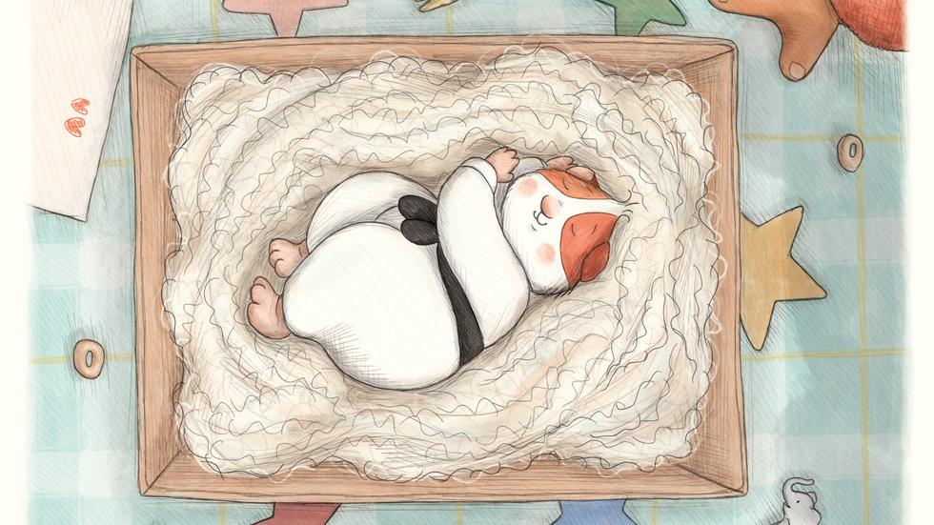

An illustration from Weirdo! by Zadie Smith and Nick Laird - a story about a judo-loving guinea pig
Call us old-fashioned, but we at The Times and The Sunday Times books sections can think of no better time to get your children reading than the summer holidays. All that time to fill, all those video games to combat.

To help you tempt your young readers, our two children’s books experts, Alex O’Connell from The Times and Nicolette Jones from The Sunday Times, have put their heads together and come up with a tempting list of 40 books for all ages, from pre-readers to inquisitive teenagers. In among their picks there are picture books, novels, fact-filled non-fiction - and even a book of football poems. All perfect material, we hope, for instilling in your children a love of reading that will last them their whole lives.

SUMMER BOOKS
Ages 0-5
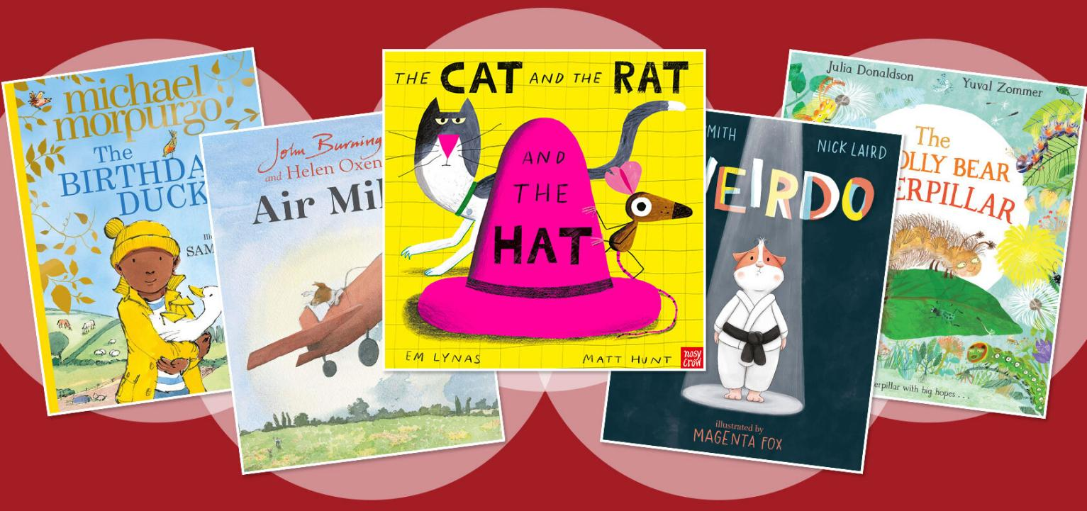

The Cat and the Rat and the Hat by Em Lynas and Matt Hunt
A stylish, funny picture book in zinging colours, with cleverly constructed rhyming text, limited vocabulary and action-packed pictures. A cat and a rat fight over a hat. A bat gets it. Great for those learning to read. NJ
Nosy Crow £6.99, ages 2-6

Weirdo by Zadie Smith and Nick Laird, illustrated by Magenta Fox
The debut children’s book and a collaborative first from a wife-and-husband team: novelist and essayist Zadie Smith and poet and novelist Nick Laird. It’s Kit’s birthday and she receives a present: a judo-loving guinea pig. But all the other pets think she’s a weirdo. A sweet, tightly written tale about the benefits of not fitting in, cheered on by Magenta Fox’s gorgeous illustrations. AOC
Puffin, £12.99, ages 3+

Barbara Throws a Wobbler by Nadia Shireen
For any child or parent that has ever had a fit of anger (so one for everyone, then). Barbara the cat is having a bad day; she can’t find her sock so doesn’t want to play when her friends invite her out. Nadia Shireen (The Bumblebear, Billy and the Beast) is one of those rare illustrator-writers who can do both equally well. AOC
Jonathan Cape, £6.99, ages 3+

The Woolly Bear Caterpillar by Julia Donaldson, illustrated by Yuval Zommer
Eric Carle died last month, but the literary caterpillar lives on. This tale with some lovely rhyming songs is all about expectations. The woolly bear caterpillar is less colourful than her caterpillar acquaintances so she presumes, as do they, that when she and they become moths, she’ll still be dowdier. In fact Woolly surprises them all — and herself: we grow, we change (perhaps the follow-up will deal with the transience of life!). AOC
Macmillan, £12.99, ages 3+

Ernest the Elephant by Anthony Browne
Anthony Browne’s tender reworking of the Good Samaritan — about a lost baby elephant who is helped by a mouse after other creatures turn away — is part visual homage to Henri Rousseau and David McKee’s Elmer, part his own trademark surrealist substitutions. NJ
Walker Books £12.99, ages 3-6

My Dad Is a Grizzly Bear by Swapna Haddow and Dapo Adeola
The book to rush out and buy for Father’s Day: about all the bearish things a dad does, the best of which is give bear hugs. Cartoony pictures are busy with comical details, and the text is lively, observant and relatable. NJ
Macmillan £6.99, ages 3-6

Grandad’s Camper by Harry Woodgate
Beautiful, textured scenes of landscapes, townscapes and gardens adorn this picture book about a grandfather mourning the loss of his male partner and remembering their travels in a camper van. His granddaughter persuades him to share splendid new adventures on the road with her. Touching and visually rich. NJ
Andersen Press £12.99, ages 3-6

Air Miles by Bill Salaman and John Burningham, illustrated by Helen Oxenbury
Before his death in 2019 John Burningham had planned this sequel to his book Motor Miles. Now resonantly and ravishingly completed, Air Miles, a farewell to the author’s Jack Russell, shows Miles the dog flying a plane on his last journey. NJ
Cape £12.99, ages 3-6

The Birthday Duck by Michael Morpurgo, illustrated by Sam Usher
Sam doesn’t want to go to the farm. “You’ll like it when you get there,” Sam’s grandad says. “I won’t,” Sam says. So begins a tale of the benefits of spreading your wings, as the city boy is told that it will do him good to be at one with nature. Michael Morpurgo, who with his wife, Clare, founded Farms for City Children at Nethercott House in Devon in 1976, knows his subject. The story is a delight from the trip there on the bus, to the feeding sheep and eating steaming porridge and scrambled eggs. Of course, “Sam loved every minute of it”. Sam Usher’s illustrations are typically beguiling. AOC
HarperCollins Children’s, £12.99, ages 4+

SUMMER BOOKS
Ages 5-9
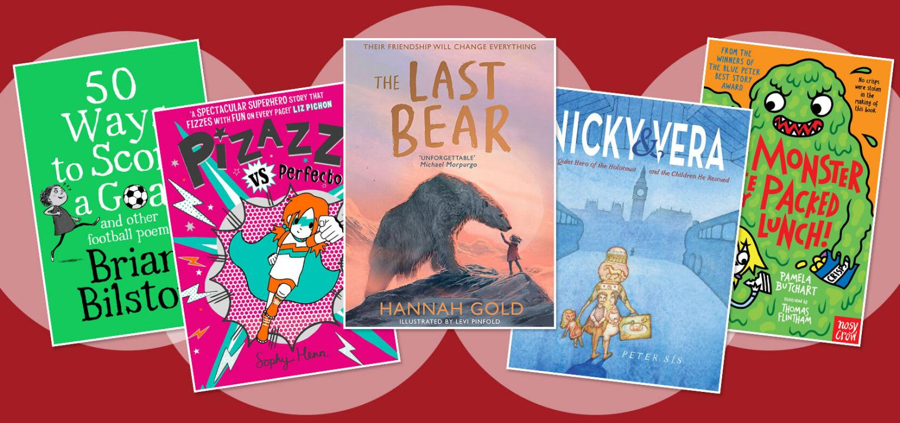

Freddie’s Amazing Bakery: The Sticky Cake Race by Harriet Whitehorn, illustrated by Alex G Griffiths
The fourth of a well-crafted series about pastry chef Freddie Bonbon and his baking adventures. This one involves cake-making tips, a contest, fancy dress, shelter dogs and a rotten cheat. With a glossary, inclusive illustrations, and recipes for would-be Bake Off stars. NJ
OUP £5.99, ages 5-7

50 Ways to Score a Goal and Other Football Poems by Brian Bilston
The poet Brian Bilston - whose Diary of a Somebody was nominated for the Costa first novel award - has written an anthology for football-mad kids. It’s funny, clever and very readable. In Pick Me! he remembers the agony of being the last person chosen for the school team. The Laws of the Game (Playground edition) contrasts the rules of football with how it’s played at break time, to great comic effect. Bilston finds humorous details everywhere. Sometimes he gets surreal imagining what an Ice-Cream Premier League might look like in Today’s Results (“Aston Vanilla 0 Rotherum and Raisin 3”). AOC
Macmillan Children’s, £7.99, ages 6+

Nicky & Vera: A Quiet Hero of the Holocaust and the Children he Rescued by Peter Sis
In December 1938 Nicholas Winton went to Prague to help the refugees who had arrived in the city after fleeing the Nazis. He raised cash, found foster families in England and arranged travel and visas for children whose parents were desperate to get them out of danger, even forging documents and bribing officials. He brought 669 children to safety. It wasn’t until nearly 50 years after the war that his actions came to light (he had told no one). In this beautiful tribute by Peter Sis, we hear the story of Winton, a former banker and Olympic fencer, and Vera, one of the Czech children he saved — and was eventually reunited with. A beautiful story told in stunning pictures and words. AOC
WW Norton, £14.99, ages 6-8

Pizazz vs Perfecto by Sophy Henn
The third part-comic-strip volume about Pizazz, who is a superhero without being a “big-headed show-off pants”. She takes on swotty girl supervillain Perfecto and both learn about kindness and the joy of being imperfect. NJ
Simon & Schuster £6.99, ages 7+

The Culture of Clothes: A Celebration of World Dress by Giovanna Alessio, illustrated by Chaaya Prabhat
This informative exploration of 30 traditional costumes, ranging from kilts and lederhosen to the outfits of gauchos, Maasai warriors, Namibian Hereros and Japanese Ryusou actors, is notable for its rich and striking illustrations. For aspiring travellers with an interest in different cultures and an eye for decoration. NJ
Templar £14.99, ages 7+

The Train Mouse by Uwe Timm, illustrated by Axel Scheffler, translated by Rachel Ward
You will recognise the work of Axel Scheffler, Julia Donaldson’s foremost illustrator, but perhaps not that of Uwe Timm, a German writer, best known for his fabulously titled classic, The Invention of Curried Sausage. I love his frank storytelling style and this tale of Nibbles, a clever, resilient mouse who lives quietly with his family in Munich until redevelopment means they have to move house. AOC
Ward Andersen Press, £9.99, ages 7+

A Monster Ate My Packed Lunch by Pamela Buchart, illustrated by Thomas Flintham
The latest book in the series by the award-winning comedy duo Pamela Buchart and Thomas Flintham. This time, Izzy and her friends are on a school trip to a lake. Gary is excited because the lodges where they’re staying have robes and slippers; but things get dark when the children realise that there is something lurking in the deep waters: a monster who wants to eat their crisps. Good jokes and lots of fun, and especially good for reluctant readers. AOC
Nosy Crow, £6.99, ages 7-9

Swan Song by Gill Lewis
Dylan’s mother is forced to give up work to home school her son, and the pair up sticks to coastal Wales where she grew up and where her father still lives a simple life. Dylan — urban, controlled, depressed — must acclimatise to a world with more freedom but no phone signal. Reading novels and learning to sail help. But the thing that really makes a difference is nurturing an injured swan. Gill Lewis makes subtle points about the way children are brought up in 2021, while falling short of preaching. This urban duckling becomes something rather beautiful. AOC
Barrington Stoke, £6.99, ages 8+

Maria’s Island by Victoria Hislop, illustrated by Gill Smith
The author of the hit adult novel The Island, set on Spinalonga, the leper colony island off the coast of Crete, has written a children’s version of that book. Victoria Hislop tells the story through the eyes of Maria, a bright girl with a wayward sister whose mother contracts leprosy and whose own diagnosis, which leads to her exile on the surprisingly cheerful Spinalonga, helps to produce a cure. AOC
Walker, £10.99, ages 8+

The Last Bear by Hannah Gold
Watch out, Michael Morpurgo, there’s a new writer of tear-jerking animal stories in town! Hannah Gold’s dazzling debut takes us to Bear Island, in the far north of Norway. Or rather, it takes April Wood there — and her father, a mad scientist type who has been charged with taking the temperature of the place. Soon April makes a friend with a difference, a polar bear whom she calls . . . Bear. Slowly, she confides in him her sad story of her father’s all-consuming grief at the loss of her mother — and Bear reveals how he got to be on Bear Island. AOC
HarperCollins Children’s, £12.99, ages 8+

SUMMER BOOKS
Ages 9-12
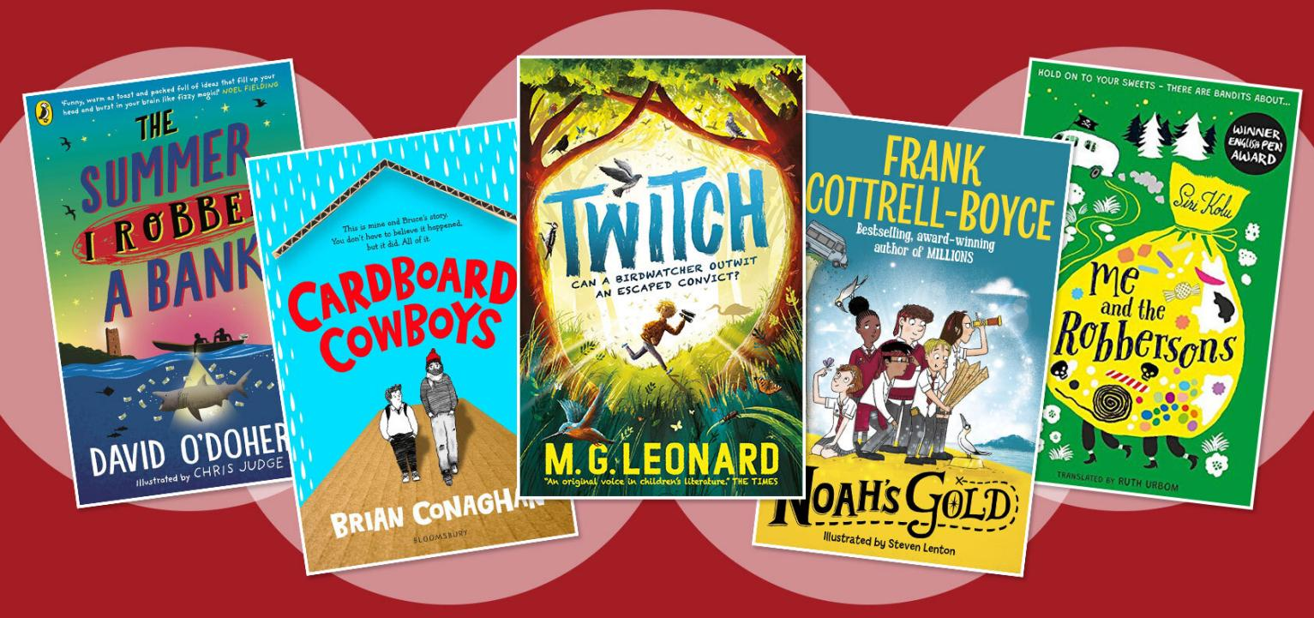

Extinct: Hallucigenia/Dunkleosteus/Trilobite by Ben Garrod illustrated by Gabriel Ugueto
Evolutionary biologist Professor Ben Garrod’s new series (of eight; the first three are out) covers the Earth’s mass extinctions over the past half a billion years, each of which erased 75-98 per cent of species on the planet — and stimulated evolution. Eye-opening science with striking artwork reveals our lost creatures. NJ
Head of Zeus £15 each, ages 8+

Twitch by MG Leonard
A lively, twisty crime drama as well as a persuasive story about friendship and protecting nature. Young bird-lover Twitch uses his bird-watching skills to track a bankrobber on the run and race to find his stolen loot. NJ
Walker Books £7.99, ages 8-10

Harklights written and illustrated by Tim Tilley
A boy makes a dramatic escape from a miserable match-factory orphanage when he encounters miniature people who protect the local forest. A magical, nature-loving narrative with a fairy-tale quality. Recommended to read aloud. NJ
Usborne £7.99, ages 8-11

The Small Things by Lisa Thompson, illustrated by Hannah Coulson
A dyslexia-friendly novella about a girl who envies others’ constant after-school activities (unaffordable for her family), and her new friend who is too ill for school and attends classes through a robot connected to her computer (a real thing). NJ
Barrington Stoke £6.99, ages 8-12

Front Desk and Three Keys by Kelly Yang
These two fabulous stories about Mia Tang were published at the start of the year. In the first, Mia, who wants to be a writer but is conflicted as her immigrant parents would rather she study maths, lives in a motel. Her parents clean the rooms, Mia works the front desk. They have a secret; they hide immigrants from Mr Yao, the hotel owner. In the second story, they now own the hotel, but Mia must deal with investors and a potential change in immigration laws that might stymie her dreams. It’s hard not to love Mia and this updated Robin Hood story. AOC
Knights Of, £6.99, ages 9+

Wave Riders by Lauren St John
A rippingly told adventure involving peril at sea, villainous millionaires, family mysteries, a contested inheritance, cruel separations, a pair of intrepid orphan twins and a dog. NJ
Macmillan £7.99, ages 9+

Me and the Robbersons by Siri Kolu translated by Ruth Urbom
This anarchic Finnish tale was selected by BookTrust’s In Other Words campaign as especially worthy of an English translation. Maisie is kidnapped by eccentric highway robbers in a van. She finds their supposedly amoral life kinder and more fun than her dull family’s. Entertainingly different. NJ
Little Tiger £6.99, ages 9-12

The Summer I Robbed a Bank by David O’Doherty, illustrated by Chris Judge
A boy with over-protective, separated parents has a wild time on a remote Irish island with his brilliantly unconventional uncle Derm, who wants to rob a bank and redistribute the money. Lots of laughs — and the odd lump in the throat. NJ
Puffin £6.99, ages 9-12

Noah’s Gold by Frank Cottrell-Boyce, illustrated by Steve Lenton
How prescient of Frank Cottrell-Boyce to construct a story about an internet outage. Noah, the boy hero of the title, has finagled his way on to his elder sister’s school trip. Yet when the teacher’s sat-nav goes awry the group end up on the uninhabited island of AranOr. Then the teacher disappears and Noah busts a pipe which not only breaks the local internet but the whole world wide web. It’s not just the students that need locating, of course, but the sense of adventure that screens can sometimes cauterise (Noah’s discovery of a treasure map helps). Very funny. AOC
Macmillan, £12.99, ages 9-12

The Swallows’ Flight by Hilary McKay
At last a follow-up to The Skylarks’ War, Hilary McKay’s wonderful 2018 story of the Penrose family’s journey through the First World War. Now the children and young folk of that novel have grown up and made way for a new set of characters who must come of age while living through a different fight, with parents who have experienced the Great War and must endure its legacies. McKay, dividing the narrative between England and Germany, refuses to dumb down the history, writing with such clarity and understanding that you can’t fail to be caught up in the cares of her loveable cast. AOC
Macmillan, £12.99, ages 9-12

Cardboard Cowboys by Brian Conaghan
Brian Conaghan, winner of the Costa children’s book award for The Bombs That Brought Us Together, understands underdogs. Lenny, an overweight 12-year-old boy, has joined a new school where he is bullied. Meanwhile, his trucker dad and depressed mother feed him stodge and dismiss him in favour of his elder brother, Frankie, who is miles away in prison, with Lenny somehow to blame for his incarceration. Enter Bruce, a homeless man who pretends to be Lenny’s dad to get him out of a fix. Then Conaghan takes this pair of cowboys on a road trip with Bruce becoming the father figure Lenny needs and Lenny becoming the responsibility Bruce craves. Their backstories get a slow, magical reveal. AOC
Bloomsbury, £6.99, ages 9-12

You Are a Champion: How to Be the Best You Can Be by Marcus Rashford written with Carl Anka and Katie Warriner
The footballer shares life lessons and practical advice he wishes he had read as a boy, encouraging reading, hard work, team-building, confidence and humility. Enlivened with anecdotes, diagrams and silhouettes, this is clear, sensible and inspiring for any age. NJ
Macmillan £9.99, ages 10+

Worst. Holiday. Ever by Charlie Higson
Stan, 12, from London, is invited to southern Italy by his rich friend Felix, whose folks have a farmhouse there. Felix’s first four choices of friends were unavailable. This allows Charlie Higson to throw Stan, an anxious, pale, skinny, lower-middle-class poor kid with a fear of life, into a moneyed middle-class group holiday and watch while he panics, flails, grows, falls in love and gives a little back to his flawed hosts. Higson, best known for his Young Bond books, as well as his TV career, is a master of pace, gentle humour and generosity. Holidays, he seems to be saying, give everyone another chance. AOC
Puffin, £6.99, ages 10-14

SUMMER BOOKS
Ages 12+
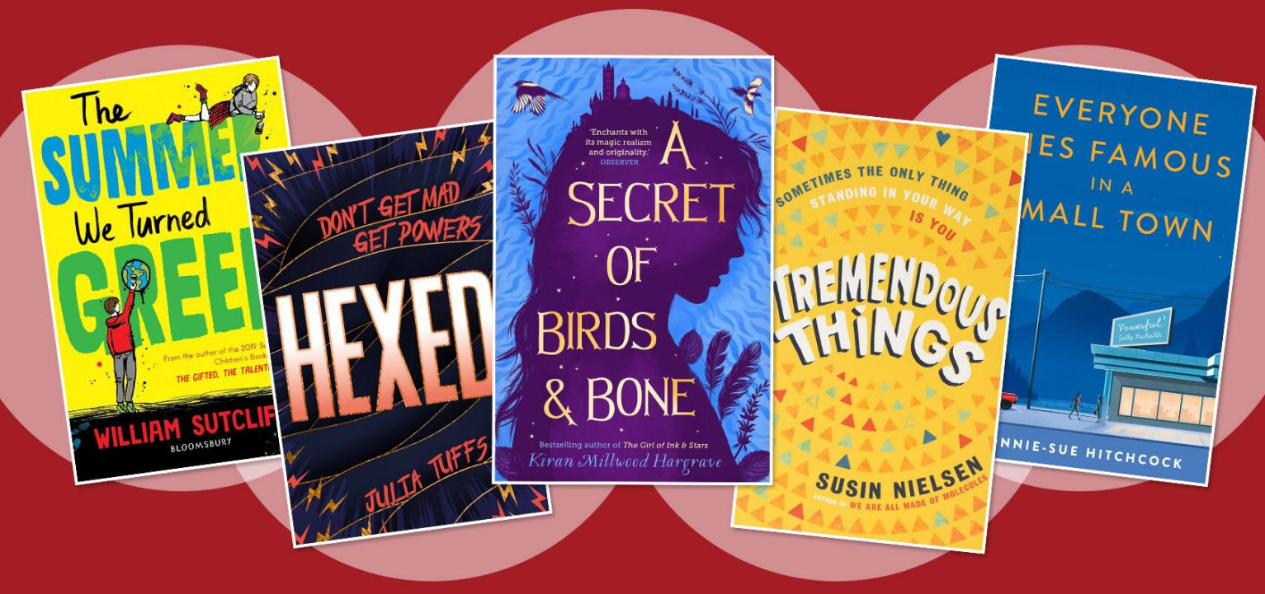

A Secret of Birds & Bone by Kiran Millwood Hargrave
Now in paperback, a remarkable magic realist novel of mystery and intrigue, set in Siena after a smallpox outbreak, and involving two children (with their pet crow) trying to rescue their mother, who makes charmed objects from bones. Atmospheric and ultimately heartwarming. NJ
Chicken House £7.99, ages 10-14

When the Sky Falls by Phil Earle
During wartime an angry boy is sent to live with the formidable Mrs F, who is trying to save the last animals in the zoo, where he finds a connection with a silverback gorilla. A raw, truthful, riveting and heartfelt tale in the tradition of Goodnight Mister Tom. NJ
Andersen Press £7.99, ages 10-14

Tremendous Things by Susin Nielsen
A candid and funny story of first love and body confidence. A home schooled boy with two mums, a pariah since being too honest on arrival in secondary school, falls for a French exchange student. Will a makeover by gay friends and an elderly neighbour give him a chance? NJ
Andersen Press £12.99, ages 10-14

Blackout by Dhonielle Clayton, Tiffany D Jackson, Nic Stone, Angie Thomas, Ashley Woodfolk and Nicola Yoon
Six top authors, including Angie Thomas who wrote The Hate U Give, come together to write a moving story of black teenage love set during a New York city summer. We follow multiple teens’ journeys through love and pain in the midst of a blackout. Perfect for bringing a taste of romance and American city life to your staycation. AOC
Electric Monkey, £7.99, ages 12+

The Summer We Turned Green by William Sutcliffe
It’s the summer holidays. Luke, 13, finds his life turned topsy turvy when his sister, Rose, and then his dad join a bunch of climate rebels protesting against airport expansion. Luke tries to save his family (his dad is now wearing sandals and drinking mead) but they just want to save the world. Boring! William Sutcliffe, who made us laugh until we wept with The Gifted, the Talented & Me, has applied his gentle humour and acute observations to this generation’s battle to save the Earth to hilarious and meaningful effect. (Published July 8) AOC
Bloomsbury, £7.99, ages 12+

Hexed by Julia Tuffs
Jessie Jones realises she is a witch when she causes Callum Henderson, an unpleasant gel-haired boy in her maths class, to develop acne. Can she really use her new powers to bring down the toxic boys in her school — or is she hexed? It’s hard to come up with a fresh witch plot, but Julia Tuffs has achieved it with Jessie in a story that is reminiscent of Sex Education and Jill Murphy’s The Worst Witch, but which also has its own strong, personal flavour. (Published July 8) AOC
Orion, £7.99, ages 12-15

Bone Music by David Almond
David Almond has just been awarded an OBE, and this lyrical novel, celebrating humanity and youth, illustrates his exceptional capacity to combine the ordinary and the visionary. A rebellious townie teenager, Sylvia, makes a journey of self-discovery through the wild landscape of Northumberland, connecting with nature and a boy she meets. NJ
Hodder £12.99, ages 14+

Everyone Dies Famous in a Small Town by Bonnie-Sue Hitchcock
If the title doesn’t grab you - but isn’t it terrific? - these coming-of-age stories of love and fury in the American west will. Bonnie-Sue Hitchcock, who came to literary attention with her elegant debut The Smell of Other People’s Houses, mines the same ground - the weird and wonderful lives of small-town kids - with breathtaking skill in this collection of interlinking stories that dart from Alaska to California. Hitchcock is insightful on sibling loyalty, poor parenting and the inherent contradiction of the small town: it is always boring but everything happens there. AOC
Faber £7.99, ages 14+

What other children’s books have you been enjoying? Share your recommendations with us.

