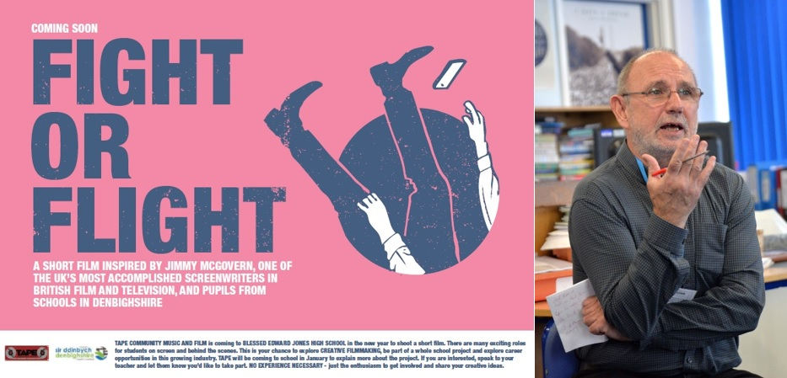

Disgyblion i wneud ffilm fer a ysbrydolwyd gan yr awdur ac enillydd BAFTA, Jimmy McGovern  Mae tipyn o gyfaredd Hollywood yn dod i Ysgol Uwchradd Gatholig Y Bendigaid Edward Jones Ddydd Mawrth 22 Ionawr 2019, wrth i’r carped goch gael ei osod ar lawr i groesawu gwestai arbennig. Bydd Paul Higginson, Is-Lywydd Gweithredol EMEA , Twentieth Century Fox, a chyn-ddisgybl yn yr ysgol, yn cyflwyno sgwrs ar wneud ffilmiau creadigol, wrth iddo lansio prosiect ffilm fer ar y cyd â ‘Tape Community Music and Film’. Hwn fydd y darn olaf mewn rhaglen sgriptio sgrin a ddechreuodd ym mis Tachwedd 2017, pan ymwelodd Jimmy McGovern, awdur ffilm a theledu a’r Ysgol.  Yn dilyn cyfres o weithdai arloesol a rhyngweithiol o ysgrifennu creadigol a chreu stori a hwyluswyd gan ‘Tape Community Music and Film yn 2018, a diolch i gyllideb oddiwrth Gronfa Addysg Thomas Howell, Gogledd Cymru, bydd Ysgol Uwchradd Gatholig Bendigaid Edward Jones yn cael ei drawsnewid I fod yn stiwdio ffilm weithgar dros tri diwrnod ym mis Chwefror, wrth i ddisgyblion wneud ffilm fer, 'Fight or Flight'. I’w cynnwys ymysg y materion y bydd disgyblion yn eu harchwilio yn eu ffilm bydd hunan-barch, delwedd y corff a chyfryngau cymdeithasol.  Dywedodd Steve Swindon, Prif Swyddog Gweithredol, ‘Tape Community Music and Film ‘bydd y prosiect yn brofiad 'aml-gyfrwng' gyda llawer o rolau cyffrous i fyfyrwyr ar y sgrin ac y tu ôl i'r llenni. Bydd hwn yn gyfle gwych i bobl ifanc archwilio ffilmiau creadigol, bod yn rhan o brosiect ysgol gyfan ac archwilio cyfleoedd gyrfaol yn y diwydiant pwysig hwn. DOES DIM ANGEN UNRHYW BROFIAD O’R BLAEN - dim ond brwdfrydedd i gymryd rhan a rhannu eich syniadau creadigol".  Felly, bobl tref y Rhyl, byddwch yn barod i wisgo eich dillad gorau a gweld ffilm unigryw 'Fight or Flight' ym mis Ebrill 2019! | Pupils to make short film inspired by BAFTA-winning writer, Jimmy McGovern  A touch of Hollywood-style glamour is coming to Blessed Edward Jones Catholic High School on Tuesday 22 January 2019, as it rolls out the red carpet for a high-profile guest. Paul Higginson, Executive Vice President EMEA for Twentieth Century Fox and former pupil at the school, will present a talk on creative filmmaking, as he launches a short film project in collaboration with Tape Community Music and Film. This will be the final piece of a screenwriting extravaganza which started in November 2017, when accomplished film and television writer, Jimmy McGovern, visited the school.  Following a series of innovative and interactive creative writing and storyboarding workshops facilitated by Tape Community Music and Film in 2018 and thanks to funding from the Thomas Howell’s Education Fund for North Wales, Blessed Edward Jones Catholic High School will be transformed into an industrious film studio over three days in February, as pupils shoot their short film, ‘Fight or Flight’. Self-esteem, body image and social media are just some of the issues pupils will explore in their film.  Steve Swindon, CEO, Tape Community Music and Film described the project as a ‘multi-media experience’… “There will be many exciting roles for students on screen and behind the scenes. This will be a wonderful opportunity for young people to explore creative filmmaking, be part of a whole school project and explore career opportunities in this growing industry. NO EXPERIENCE NECESSARY - just an enthusiasm to get involved and share your creative ideas.”  So, Rhyl, you’d better get your ball gowns and tuxedos ready for the exclusive film premiere of ‘Fight or Flight’ in April 2019!

