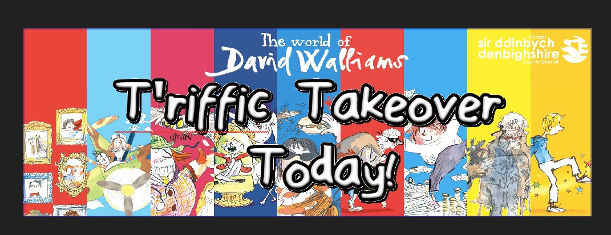

10 ffaith am Gŵylgyfoeth 2018  “Bod yn Fi” – Dathlu Gwahaniaeth  - Ym mis Mehefin 2017, cafodd ein ffynhonell fewnol wybodaeth fod cyhoeddwyr David Walliams, HarperCollins, yn cynllunio nifer o ddigwyddiadau arbennig trwy gydol 2018, er anrhydeddu 10 mlynedd o ‘The World of David Walliams’.  - Mewn ymateb, mae menter Cyfoethogi Cwricwlwm Gwasanaethau Addysg a Phlant Sir Ddinbych curadodd ei gasgliad eithriadol ei hun ar gyfer Hâf Gwanwyn 2018 – sef dathliad gogoneddus o unigrywrwydd - i nodi pen-blwydd yn ddeg o nofel gyntaf David Walliams, ‘Y Bachgen mewn Ffrog', y llyfr hynod boblogaidd a doniol am fachgen nad yw'n ofni bod yn wahanol!  - Ym mis Tachwedd 2017, cawsom “IE” gan David a gwahoddiad personol gan HarperCollins i ymuno â nhw wrth iddynt hyrwyddo rhaglen o gystadlaethau a mentrau ysgol trwy gydol 2018 a rhannu ein hadnoddau gyda nhw yn y flwyddyn ddathlu hon.  - Yn dilyn rhagolwg rhyfeddol hwn o’r hwyl fydd ar gael, cafodd Gwylgyfoeth 2018 ei lansio'n ffurfiol ym mis Chwefror 2018, ac yn gaddo’r fath wledd o weithgareddau trawsgwricwlaidd cyffrous i ysgolion Sir Ddinbych am unigolrwydd ac amrywiaeth yn ei holl ffurfiau.  - Cafodd ein casgliad unigryw ei gynllunio i gefnogi gofynion statudol y cwricwlwm ysgol presennol a gellir ei chyflwyno ar draws llawer o feysydd cwricwlaidd i ysbrydoli'ch myfyrwyr.  - Wedi'i lunio ar nofel gyntaf David Walliams, 'Y Bachgen mewn Ffrog’, gan dderbyn ysbrydoliaeth gan awduron eraill i blant a phobl ifanc, gan gynnwys Hans Christian Andersen (‘The Ugly Duckling’), Julia Donaldson (‘Tyrannosaurus Drip’), Jacqueline Wilson (‘Bad Girls’), Rumer Godden (‘The Diddakoi’), RJ Palacio (‘Wonder’) a William Golding (‘Lord of the Flies’), nod Sir Ddinbych yw croesawu a dathlu gwahaniaethau, parchu amrywiaeth, cerdded yn falch a gyda steil a dod yn esiampl i Gymru gyfan wrth wneud hynny.  - Efo’n gilydd, cymerasom agwedd plentyn i: -  - drafod', pinio i lawr a smwddio problemau bach a mawr bywyd mewn ffordd dyfeisgar;  - rhoi’r modd i unigolion arddangos eu natur unigryw ac arddull unigol;  - arddangos, fod lle pwysig i’r darn lleiaf a’r darn mwyaf o'r patrwm, i ddathlu pwysigrwydd pob elfen o'r dilledyn terfynol;  - pwytho’r holl ddarnau at ei gilydd ar gyfer y gosod terfynol;  - dathlu pa liw, siâp neu unigrywdeb bynnag unrhyw wisg a’r gwaith dylunio sydd y tu ôl i'w creu;  - lansio a dathlu'r casgliad lliwgar ac amrywiol;  - camu â balchder ar hyd y rhedfa ffasiynau.  - Ym mis Mehefin 2018, gwnaethom arddangos y casgliad Gwanwyn Hâf 2018, gyda chyfres o ‘Drosfeddiannau T’riffic’, pryd atalodd ysgolion eu hamserlen arferol ar gyfer y diwrnod cyfan.  - Ar y dyddiau hynny, llifodd disgyblion yn rhwydd trwy giatiau'r ysgol am ddiwrnod o hwyl sy'n seiliedig ar lenyddiaeth, wedi'u gwisgo ym mha beth bynnag maen nhw am ei wisgo - efallai hyd yn oed un o'u hoff gymeriadau Walliams.  - Gan ddefnyddio Celfyddyd Llwyfan a Pherfformiad, cynlluniasom dwy raglen ar wahân, un yn addas ar gyfer plant 5-11 oed ac un ar gyfer plant 11-16 oed. Ymdrechodd y ddwy raglan i arddangos a dathlu pob math o wahaniaeth ac unigolyniaeth mewn modd creadigol a chynhwysol. | Top 10 facts about Enrichfest 2018  “Being Me” – Celebrating Difference  - In June 2017, our eagle-eyed inside informant had a tip-off that David Walliams’ publishers, HarperCollins, were planning a number of special events throughout 2018, in honour of the 10 year anniversary of ‘The World of David Walliams’.  - In response, Denbighshire Education and Children’s Services’ Curriculum Enrichment initiative curated its own extraordinary 2018 Spring Summer collection – a glorious celebration of individuality - to mark the 10th anniversary of David Walliams’ debut novel, ‘The Boy in the Dress’, the hilarious bestseller about a boy who isn’t afraid to be different!  - In November 2017, we had a “YES” from David and a personal invitation from HarperCollins to join them in promoting a programme of school competitions and initiatives throughout 2018 and to share OUR resources with them in this celebration year.  - Following a tantalising preview of its delights, Enrichfest 2018 was formally launched in February 2018, promising Denbighshire schools an exciting cross-curricular spectacle of individuality and diversity in all its forms.  - Our exclusive collection was designed to support the statutory requirements of the current school curriculum and could be delivered across many curricular areas to inspire students.  - Modelled on David Walliams’ debut novel, ‘The Boy in the Dress’, and drawing inspiration from other writers for children and young people, including Hans Christian Andersen (‘The Ugly Duckling’), Julia Donaldson (‘Tyrannosaurus Drip’), Jacqueline Wilson (‘Bad Girls’), Rumer Godden (‘The Diddakoi’), RJ Palacio (‘Wonder’) and William Golding (‘Lord of the Flies’), Denbighshire’s aim was to embrace and celebrate differences, respect diversity, walk the catwalk, strut our stuff with aplomb and become Wales’ exemplar.  - Together, we took a child’s eye-view to:-  - ad-‘dress’, pin down and iron out life’s big and little creases in an inventively ‘sew-sew’ way;  - accessorise and encloak participants to display their uniqueness and individual style;  - showcase, from the smallest to the largest, tailor-made piece of the pattern, to celebrate the importance of each component of the final garment;  - sew all the pieces together for a final fitting;  - celebrate whatever colour, shape or uniqueness of any outfit and the design work taken to create them;  - launch and celebrate the colourful and diverse collection;  - stride with pride and take off on the runway.  - In June 2018, we showcased the 2018 Spring Summer collection with a series of ‘T’riffic Takeover Days’, when schools suspended their normal timetable for the day.  - On those days, pupils gleefully streamed through their school gates for a day of literature-based fun, dressed in whatever they wanted to wear – maybe even as one of their favourite Walliams characters.  - Using Stagecraft & Performance, we designed two separate programmes, one suitable for 5-11-year olds and one for 11-16-year olds. Both programmes endeavoured to showcase and celebrate all types of difference and individuality in a creative and inclusive way.

