MAI 2018 | MAY 2018

'The Great Gingerbread Gallop'  - diwrnod blasus tu hwnt! |  | ‘The Great Gingerbread Gallop’  - a truly taste-bud tickling day!
Am ddiwrnod blasus tu hwnt! Ymwelwyd ag un ar bymtheg o Ysgolion Sir Ddinbych mewn taith o gwmpas y Sir ar frys gan un o hoff gymeriadau llyfrau David Walliams, fel rhan o brosiect Gwylgyfoeth 2018 eleni, wrth i ni ddathlu 10 mlynedd ers i awdur plant mwyaf poblogaidd y DU, sef David Walliams, gychwyn ysgrifennu.  Mae Mrs Trafe (mewn gwirionedd yr actor Stuart Loughland), un o gymeriadau’r llyfr y ‘Billionaire Boy’, a ddisgrifir gan Walliams fel "cogydd ysgol ffiaidd, sy’n aml yn arlwyo prydau bwyd afiach", gydai "safonau hylendid ddiffygiol", yn difyrru plant wrth ddatgelu rhai prydau arbennig fydd yn cael eu cyflwyno yn neuaddau cinio ysgolion Sir Ddinbych fis Mehefin 2018, gan gynnwys 'Road-Kill Bake', 'Deep-fried Cardboard' a 'Slice of Sweat Cake', cyn iddi ddosbarthu bisgedi sinsir (nifer cyfartal o ferched a bechgyn).  Mae menter Cyfoethogi Cwricwlwm Sir Ddinbych wedi trefnu cystadleuaeth ysgolion gyffrous trwy gydol mis Mehefin 2018, o dan y teitl ‘David's Dunkin' Delights’ - “Addurnwch eich bisgedi sinsir a’u gwneud yn Hardd”… lle gall 1,460 disgybl drwy’r Sir oedran 5-7archwilio a datblygu sgiliau pwrpasol ac ymarferol ac ymhyfrydu mewn addurno eu bisgedi sinsir, a’u gwisgo mewn unrhyw fodd yn ol eu dymuniad - hyd yn oed modd a ysbrydolwyd gan un o'u hoff gymeriadau o lyfrau Walliams.  Mae'r gystadleuaeth yn cael ei noddi a'i feirniadu gan The Pudding Compartment Ltd, Fflint, gyda chymorth 'The Walliams Gang', y tîm creadigol sydd y tu ôl i brosiect eleni.  ADDEWID GAN WASANAETH PRYDAU BWYD YSGOLION SIR DDINBYCH: Ni chymerodd Mrs Trafe unrhyw ran mewn pobi’r bisgedi sinsir hyn! | 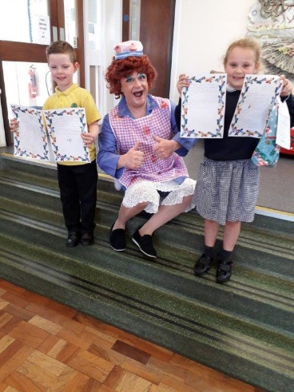  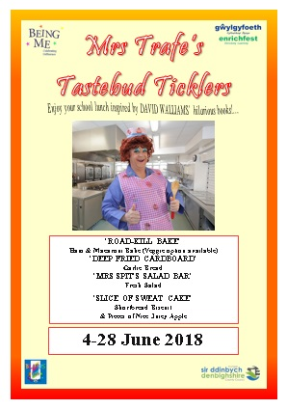  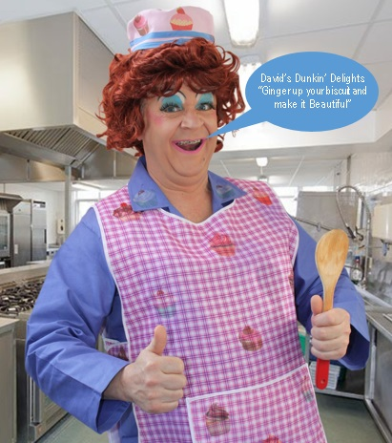 | What a truly taste-bud tickling day! Sixteen Denbighshire Schools were visited in a whirlwind county tour by one of David Walliams’ favourite book characters, as part of this year’s Enrichfest 2018 project, celebrating 10 years of the UK’s No. 1 best-selling children’s author, David Walliams.  Mrs Trafe (aka actor Stuart Loughland), a character from ‘Billionaire Boy’, described by Walliams as “an abominable school cook, often serving up monstrous concoctions”, whose “standards of hygiene are sorely lacking”, delighted the children by revealing some dishes that will be served up in Denbighshire’s school canteens throughout June 2018, including ‘Road-Kill Bake’, ‘Deep Fried Cardboard’ and ‘Slice of Sweat Cake’, before distributing gingerbread biscuits (girls and boys).  Denbighshire’s Curriculum Enrichment initiative has organised an exciting schools’ competition throughout June 2018, entitled ‘David’s Dunkin’ Delights’ – “Ginger up your biscuit and make it Beautiful”, where 1,460 pupils aged 5-7, can explore and develop purposeful and practical skills and delight in decorating their gingerbread biscuits, dressed in whatever they want their characters to wear – maybe even inspired by one of their favourite Walliams’ characters.  The competition is being sponsored and judged by The Pudding Compartment Ltd, Flint, assisted by ‘The Walliams Gang’, the creative team behind this year’s project.  AN ASSURANCE FROM DENBIGHSHIRE SCHOOL MEALS SERVICE: Mrs Trafe had no hand in baking these gingerbread biscuits!

