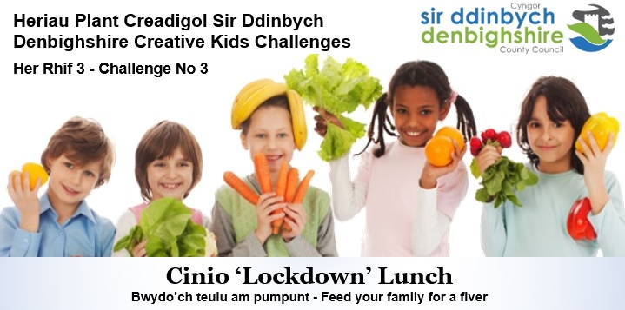

‘Lockdown’ Lunch: Feed your family for a fiver
Contest encourages children and families to cook together during COVID-19

The third exciting Denbighshire Creative Kids Challenges invited children and young people to invent a healthy lunch they would cook for their family during ‘lockdown’ - as many courses as they liked - for no more than £5.

Paula Roberts, Denbighshire Healthy Schools Co-ordinator said, “We hope to inspire children and young people throughout Denbighshire to get cooking in what promises to be an aspirational, fun and enjoyable cooking contest. This challenge aims to find and encourage talented young cooks who have a flair for making exceptional food from scratch. It’s also an ideal way to encourage children to try new dishes that include healthy ingredients like fruits and vegetables.”

Judge, Teleri Owen, Teacher of Food Technology at Denbigh High School, said, “I’ve been inspired by the youngsters’ passion for cooking and their creativity. I’ve been motivated to try some of the dishes with my family after seeing the culinary creations the children have developed. It’s wonderful knowing that we are helping to inspire future generations to make positive food choices.”

Denbighshire children between the ages of 4 and 14 submitted their healthy and tasty creations. The winners were selected on nutritional value, taste and originality. Each will receive a copy of ‘Nadiya's Bake Me a Story: Fifteen stories and recipes for children’, a unique combination of storybook and cookbook by ‘Great British Bake Off’ sensation Nadiya Hussain, bringing families into the kitchen to spend time together, sharing stories and cooking.

Up to 7 years
- Caitlin Chatterton, Y2, St Asaph VP Infants

7-11 years - Joint Winners
- Emilia Roberts, Y4, Ysgol Llywelyn, Rhyl
- Emelia Williams, Y6, Ysgol Borthyn, Ruthin

12-14 years
- Isla Thomson, Y7, St Brigid’s School, Denbigh
