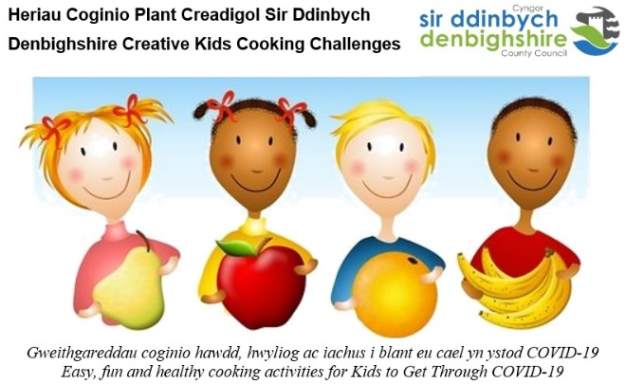

Denbighshire Creative Kids Cooking Challenges
A little Cooking Competition is Healthy

Denbighshire Healthy Schools and Curriculum Enrichment Initiative have taken the liberty of whipping up cooking challenges for children and young people to help them get through COVID-19.

In the first challenge - ‘FLAVOUR’-ITE BITES’, Denbighshire children and young people were invited to show off their culinary skills and impress top judge, Jane Jones, School Cook at Ysgol Twm o’r Nant, Denbigh and Wales Cook of the Year 2020, by coming up with an idea of what their favourite book, TV or movie character would like to eat. The snacks were to be healthy, easy and fun to make, super-tasty and well-presented on a plate. All entries were submitted by e-mail, listing ingredients, snack recipe, choice and name of snack, accompanied by a photograph.

Paula Roberts, Denbighshire Healthy Schools Co-ordinator said, “Children and young people can cook and compete in ways that encourage them to try new foods and have fun creating healthy snacks. Helping in the kitchen builds confidence and encourages independence, plus it’s a valuable contribution to the family. Not only do we want children and young people to learn cooking and safety skills, we want them to enjoy creating and experimenting and tasting! That’s what these Creative Cooking Challenges are all about - trying new foods, creating unique dishes, and spending time in the kitchen”.

Commenting on the large number of entries received, Jane Jones, competition judge said, “We received an impressive range of entries representing an excellent standard of work and effort. All the dishes created by the children and young people looked terrific, showing great use of ingredients. I might have to use try some of these at school! It was very difficult to pick out winners but after a lot of head-scratching, I chose the following winners in each category” -

Up to 7 years
Milly Clarke, Y2, Bodnant Community School

7-11 years
Annie Evans, Y6, Ysgol Carreg Emlyn

12-14 years
Isla Thomson, Y7, St Brigid’s School
