Bwydlen Fawr Sir Ddinbych 2018  ‘Bwyta’n Dda a la David’...  Mae cystadleuaeth Bwydlen Fawr Sir Ddinbych wedi'i gynllunio ar gyfer disgyblion Ysgol Gynradd ac Uwchradd, rhwng 7 a 14 oed, i ysbrydoli plant a phobl ifanc i ddilyn eu cariad am fwyd a choginio, gan gynnig cyfle iddynt ymestyn eu dysgu y tu hwnt i'r ystafell ddosbarth a rhoi iddynt llwyfan i gynrychioli eu hysgol ar lefel sirol, tra'n hyrwyddo ac arddangos pa mor glyfar ydynt wrth goginio.  Gan ddychwelyd am y bedwaredd flwyddyn lwyddiannus, thema cystadleuaeth eleni oedd 'Bwyta’n Dda a la David', i anrhydeddu a dathlu pen-blwydd 10 mlynedd o gyhoeddi llyfrau un o’r awduron plant mwyaf poblogaidd David Williams a’i Fyd Unigryw.  Trwy gydol tymhorau'r Gwanwyn a'r Haf 2018, mae cogyddion ifanc mewn ysgolion ar draws Sir Ddinbych wedi ymwisgo efo’u ffedogau, wedi archwilio a datblygu sgiliau pwrpasol ac ymarferol a phrofi eu hyfedredd coginio, eu creadigrwydd a'u sgiliau, mewn ymgais personol i gyrraedd 'Y Banquet Fawr' (sef y Prif Rownd Terfynol).  Ar 2il a 3ydd Gorffennaf 2018, roedd y ‘menig popty’ i ffwrdd yn Ysgol Uwchradd Dinbych, pan roddwyd sialens neu her annisgwyl i gogyddion ifanc o bob cwr o'r sir – sef 'Teaser Technegol' – oedd yn brawf o’u gwybodaeth technegol a'u profiad. Profwyd nad tynnu coes oedd hwn jooedd 'melyn' ond 'wyg-citond rhywbeth cynhyrfus tu hwnt ! Dros dau ddiwrnod, treuliodd cogyddion ifanc eu hamser yn brwydro gyda'i gilydd ac yn codi i'r her.  Roedd y panel beirniadu'n cynnwys: barnwr cogyddio gwadd, Graham Tinsley MBE; Steve West, Rheolwr Gyfarwyddwr, Y Pudding Compartment; Ian Kemp a Hayley Jones, Rheolwyr Gwasanaethau Arlwyo Sir Ddinbych; Teleri Owen, Ysgol Uwchradd Dinbych, yn ogystal â Mrs Trafe o lyfr David Walliams 'Billionaire Boy - y math o wraig cinio sy'n rhoi hunllef i bobl! .  Cymerodd Ysgol Bro Famau y wobr yn y categori oedran 7-11, gyda ‘Starter’ :'Showsy-Wosey' gyda ‘Teisen Wyneb i Waered David', tra ‘roedd Ysgol Uwchradd Dinbych yn fuddugol yn y gystadleuaeth 11-14, gyda Phrif Gwrs 'Dŵr at Ddannedd’ Chokky-Wokky Ravishing Roulade David ', er mwyn plesio blas David Walliam a rhai o'i hoff gymeriadau o’i lyfrau.  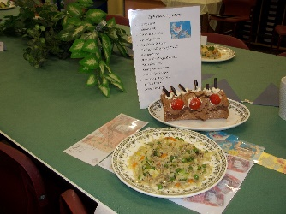  Gwelodd y rownd derfynol safon uchel iawn o gystadleuaeth. Dywedodd y barnwr gwadd, Steve West, Rheolwr Gyfarwyddwr The Pudding Compartment, Y Fflint "Roedd safon y coginio yn wych. Dylai pawb yn y rownd derfynol fod yn falch ohonynt eu hunain. Mae'n rhoi ysbrydoliaeth i mi weld y bobl ifanc yn cynhyrchu canlyniadau mor ysblennydd ". Ychwanegodd, "Mae gan y cystadleuwyr yn rownd derfynol ddyfodol disglair o'u blaenau."  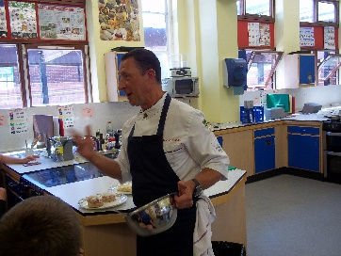  Noddwyd Bwydlen Fawr Sir Ddinbych 2018 gan The Pudding Compartment, Y Fflint. Lluniwyd yr holl sialensau i herio’r cystadleuwyr gan Mrs Teleri Owen, Ysgol Uwchradd Dinbych. Beirniadodd y cogydd enwog Graham Tinsley MBE yr her 11-14 cyn arddangos ei sgiliau i gogyddion Ysgol Uwchradd ifanc a rhywfaint o’r hwyl sydd i goginio yn ystod y prynhawn mewn dosbarth feistr coginio.  Y Cogydd Enwog  Graham Tinsley MBE  Celebrity Chef  Mae Gwasanaethau Addysg a Gwasanaethau Plant Sir Ddinbych 'wrth eu bodd fod cymaint o blant a phobl ifanc wedi cymryd rhan yng nghystadleuaeth Bwydlen Fawr Sir Ddinbych 2018 ac maent wrthi eisoes yn paratoi rhywbeth ‘blasus’ ac arbennig ar gyfer 2019! | 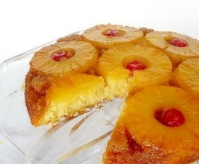  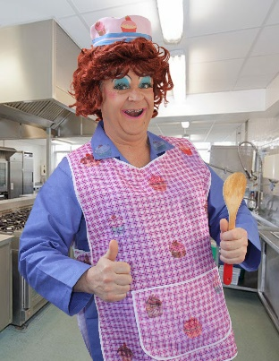  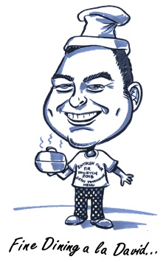  ‘David’s Bottom-Up Dessert’  ‘David’s Chokky-Wokky Ravishing Roulade’  Mrs Trafe | Great Denbighshire Menu 2018  ‘Fine Dining a la David’…  The Great Denbighshire Menu competition is designed for Primary and Secondary School pupils, aged between 7 and 14, inspiring children and young people to pursue their passion for food and cookery, offering them the opportunity to extend their learning beyond the classroom and providing them with a platform to represent their school at county level, while advancing and showcasing their culinary cleverness.  Returning for a fourth successful year, the theme for this year’s competition was ‘Fine Dining a la David’, in honour of the 10 year anniversary of ‘The World of David Walliams’, No 1 bestselling children’s author.  Throughout the Spring and Summer terms 2018, young chefs in schools across Denbighshire have donned their aprons, explored and developed purposeful and practical skills and proved their cooking prowess, creativity and skill, in a bid to reach the ‘The Big Banquet’ (grand final).  On 2nd & 3rd July 2018, the oven gloves were off at Denbigh High School, when young chefs from across the county were set a final, unseen, challenge - a ‘Technical Teaser’ – testing their technical knowledge and experience. It proved to be no ‘yolk’ but very ‘egg-citing’. Over two days, young chefs spent their time mixing it with each other and rising to the challenge.  The judging panel comprised: chef guest judge, Graham Tinsley MBE, Steve West, Managing Director, The Pudding Compartment, Ian Kemp and Hayley Jones, Denbighshire Catering Services’ Managers, Teleri Owen, Denbigh High School, as well as Mrs Trafe from David Walliams’ Billionaire Boy - the kind of lunch lady that nightmares are made of! .  Ysgol Bro Famau took the honours in the 7-11 age category, with a ‘Showsy-Wosey’ Starter and ‘David’s Bottom-up Dessert’, whilst Denbigh High School was victorious in the 11-14 competition, with a ‘Mouth-Watering’ Main and ‘David’s Chokky-Wokky Ravishing Roulade’, to tickle David Walliams’ taste buds and some of his favourite book characters.  The Finals saw a very high standard of competition. Guest judge Steve West, Managing Director of The Pudding Compartment, Flint, said “The standard of the cooking was phenomenal. All of the finalists should be proud of themselves. It gives me inspiration to see the youngsters produce such spectacular results”. He added, “The finalists have a bright future ahead of them.”  The Great Denbighshire Menu 2018 was sponsored by The Pudding Compartment, Flint. All challenges were devised by Mrs Teleri Owen, Denbigh High School. Celebrity chef Graham Tinsley MBE judged the 11-14 challenge and thrilled the young Secondary School chefs with some culinary fun in the afternoon with a cookery masterclass.  Denbighshire Education and Children’s Services’ is delighted that so many children and young people took part in this year’s Great Denbighshire Menu 2018 competition and is already ‘cooking’ up something special for 2019!

