Taith ar fwrdd Wizarding Express Sir Ddinbych...
All aboard the Denbighshire Wizarding Express…

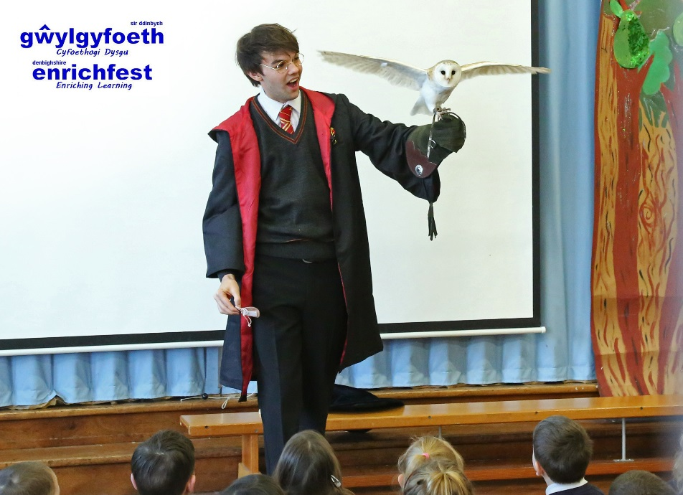

Mae criw ‘Wizarding Express’ Cyfoethogi’r Cwricwlwm Adran Addysg a Gwasanaethau Plant Sir Ddinbych 'wedi bod yn brysur yn tyfu digon o stêm yn y boilar ar Blatfform 9¾ ac maent yn barod i groesawu 16 o ysgolion ar fwrdd am antur fwyaf eu bywydau, i ddathlu 20 mlynedd ers y cyhoeddiad cyntaf 'Harri Potter a Maen yr Athronydd' - taith traws-gwricwlaidd o'r safon uchaf, yn llawn "hud, swyn, a llawer mwy o stwff ‘bewitching".  Nod Sir Ddinbych yw cael bod yn arweinwyr, i gario'r torch fflam a chwifio baner Harri Potter dros Gymru yn ystod y pen-blwydd nodedig hwn.  Un o uchafbwyntiau’r lansiad fu cyfres o ymweliadau ysgol ‘Cyfarfyddiadau Tylluan’ gan Harri Potter a rhai o'i ffrindiau, gan gynnwys Hedwig, ei dylluan wen eira anwes. Cyflwynwyd ysgolion gyda 'Phecynnau Teithio i'r Ysgol' ar gyfer y siwrne, gan gynnwys gweithgareddau, cystadlaethau a manylion am drosfeddiannu eu hysgolion, fydd yn digwydd ym mis Mehefin 2017.  Mae’r prosiect Cyfoethogi’r Cwricwlwm Sir Ddinbych 2017 wedi ei gynllunio gyda saith gydran cyffrous:-  - Pottero o Gwmpas (Llythrennedd Digidol)  - Cwilio Castiog (Ysgrifennu Creadigol)  - Brwydr Pobi Harri Potter (Dylunio a Thechnoleg / Coginio a Maeth)  - O’r Fath Gyffro (Celf a Dylunio)  - Campau Cemegol (Gwyddoniaeth, Technoleg, Peirianneg, Mathemateg)  - Harri-oddiad (Gwneud Ffilmiau a’r Cyfryngau Gweledol)  - Trosfeddiannu Ysgolion, gyda Gweithdai West End Rhyfeddol Hudol (Actio, Canu a Dawnsio)  Drwy gydol Tymor y Gwanwyn a'r Haf 2017, bydd dewiniaid ifanc, gwrachod a'u hathrawon, yn hynod o brysur yn astudio "un o anturiaethau llenyddol mwyaf y cyfnod fodern", wrth weithio gyda'i gilydd yn greadigol ar draws y cwricwlwm.  Ar gyfer holl newyddion cyffrous am y fenter ac unrhyw ddiweddariadau wrth i ni ddatblygu Cyfoethogi’r Cwricwlwm yn Sir Ddinbych ac i dderbyn rhagor o wybodaeth am brosiect Harri Potter 2017, ewch i'n gwefan gyffrous a lliwgar –  denbighshireenrichment.com  Dilynwch ni ar Trydar @cyfoeth_enrich #MaenYrAthronydd@20 | The crew of the Denbighshire Education and Children’s Services’ Curriculum Enrichment ‘Wizarding Express’ has been steadily building up a head of steam on Platform 9¾ and was delighted to welcome 16 schools on board for the adventure of a lifetime, celebrating the 20th anniversary of the first publication of ‘Harry Potter and the Philosopher’s Stone’ – a cross-curricular journey of the highest quality, full of “spellbinding, enchanting, bewitching stuff”.  Denbighshire’s aim is to be leaders, carrying the flaming torch and flying the Harry Potter flag for Wales during this landmark anniversary.  One of the stand-out highlights so far has been a series of ‘Owl Encounters’ school visits by Harry Potter and some of his pals, including Hedwig, his pet snowy white owl. Schools were presented with their official ‘School Travel Packs’ for the journey, including activities, competitions and details of exciting Schools Takeovers, which will take place in June 2017.  Denbighshire’s Curriculum Enrichment 2017 project is designed with seven exciting components:-  - Potterin’ About (Digital Literacy)  - Quirky Quilling (Creative Writing)  - Harry Potter Cake-Off (Design & Technology / Cooking and Nutrition)  - All of a Flutter (Art & Design)  - Chemical Capers (Science, Technology, Engineering, Mathematics)  - Harry-tage (Film-making & Visual Media)  - Schools Takeovers, with Wizardly Wondrous West End Workshops (Acting, Singing and Dancing)  Throughout the Spring and Summer terms 2017, schools will be packed to the rafters with young wizards, witches and their professors, eager to explore “one of the greatest literary adventures of modern times”, as they work together creatively across the curriculum.  For all the latest exciting news and updates in Denbighshire Curriculum Enrichment and to receive more information about the 2017 Harry Potter project, visit our exciting and colourful website –  denbighshireenrichment.com  Follow us on Twitter @cyfoeth_enrich  #PhilosophersStone@20

