**“Let’s Get Writing” with Alan Harris**

**Wednesday 18 October 2017**

**An exclusive opportunity for students at**

**Denbigh High School & Blessed Edward Jones RC High School**

When students from Denbigh High School and Blessed Edward Jones RC High School, entered a creative writing competition earlier this year entitled *‘Quirky Quilling’* to celebrate the 20th anniversary of ‘*Harry Potter and the Philosopher’s Stone’*, little did they know at the time that their wizarding scribbling would result in a truly unique, magical event involving a critically acclaimed writer visiting their schools.

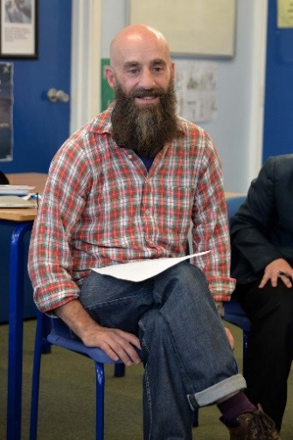Alan Harris is an award-winning Welsh playwright. His play ‘A *Good Night Out in the Valleys’* launched the new National Theatre Wales and he has worked with theatre companies throughout the United Kingdom. He won a Judges’ Award at the 2015 Bruntwood Prize for his play *‘How My Light is Spent’* at the Royal Exchange, Manchester. He also wrote ‘*The Opportunity of Efficiency’* - the first international collaboration for National Theatre Wales with the New National Theatre Tokyo. Alan has written several plays for BBC Radio 4 and Radio 3 and is part of the BBC Drama Room scheme for 2017.

On Wednesday 18 October 2017, students joined Alan Harris for a series of creative writing workshops and were given a first-hand insight into the secrets behind the creative process.

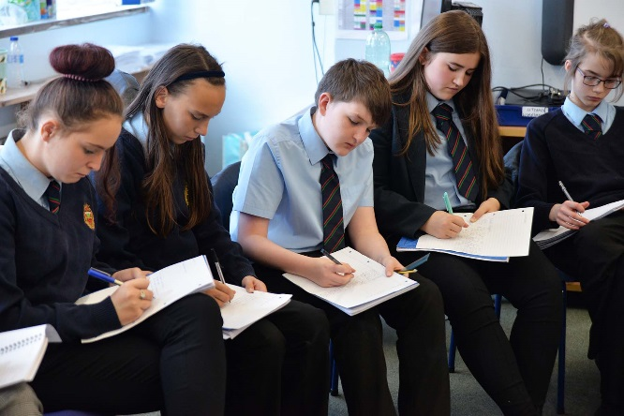

Throughout the workshops, students were encouraged to think of themselves as writers and discover their own powerful, unique voices.

A primary aim and objective of the workshops was to stimulate students’ own creative thinking and to improve their own particular writing style and skills and, at the same time, emphasise how much fun and personal enjoyment they could gain from the experience.

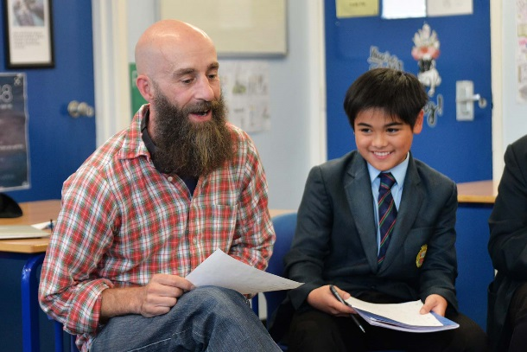Alan Harris skilfully guided the students through a series of creative writing exercises in a thought-provoking and entertaining way. The students experienced dynamic learning styles which included performance and story-telling, alongside written work, in order to introduce them to the key elements of building a story. Students spent most of their time putting pencil to paper, trying out all the new things they had learnt. At the end of the workshops, there was a wonderful opportunity for both tutor and students to share extracts from a selection of their own work written on the day.

On the day, Alan Harris and the students demonstrated how the power of the written word and expertly woven stories, based on personal experience, can help solve often seemingly insurmountable problems faced by young people.