LLYFRAU NADOLIG | CHRISTMAS BOOKS
Presents that will capture young imaginations
0-to 4-year-olds
- Welcome (Egmont £10.99, 3+) by Barroux
- Winnie and Wilbur Meet Santa by Valerie Thomas (OUP £12.99, 3+)
- All My Treasures: A Book of Joy by Jo Witek, illustrated by Christine Roussey (Abrams £10.99, 3+)
- Hello, Mr Dodo (Alison Green £6.99, 3+) by Nicholas John Frith
- The Building Boy by Ross Montgomery (Faber £6.99, 4+)
- Pandora by Victoria Turnbill (Frances Lincoln £11.99, 2-6)
- A Bottle of Happiness by Pippa Goodhart (Tiny Owl £12.99, 4+)
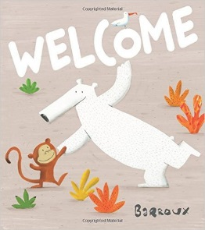
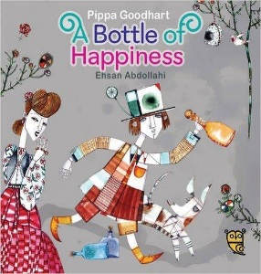
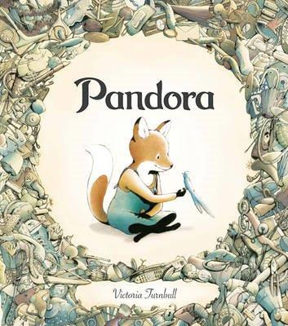
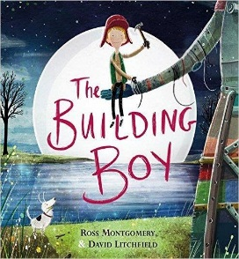
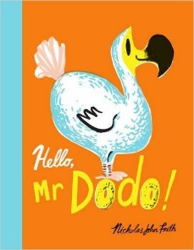
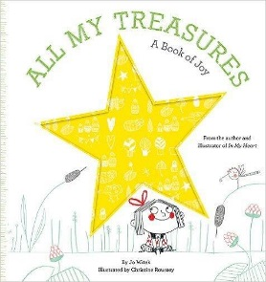
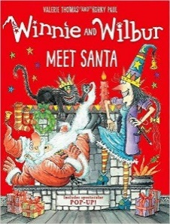

7-to 12-year-olds
- AniMalcolm by David Baddiel, illustrated by Jim Field (Harper Collins £12.99, 8+)
- Double Down by Jeff Kinney (Penguin £12.99, 8+)
- Tom Gates: DogZombies Rule (For Now) by Liz Pichon (Scholastic £10.99, 8+)
- Lesser Spotted Animals by Martin Brown (David Fickling £12.99, 7-12)
- The Secret of Nightingale Wood by Lucy Strange (Chicken House £6.99, 9+)
- The Song from Somewhere Else by AF Harrold, illustrated by Levi Pinfold (Bloomsbury £12.99, 9+)
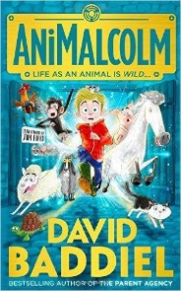
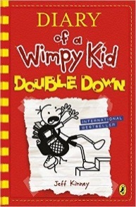
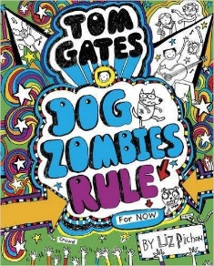
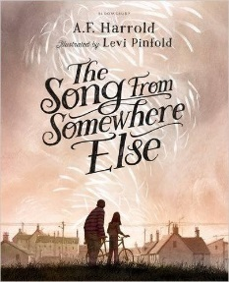
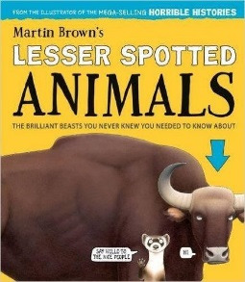
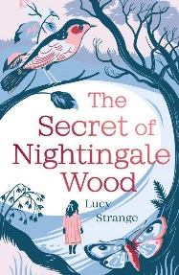

Over 13s
- The Lie Tree by Frances Harding, illustrated by Chris Riddell (Macmillan £12.99, 11+)
- Kid Got Shot (The Garvie Smith Mysteries) by Simon Mason (David Fickling £10.99, 13+)
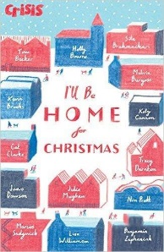
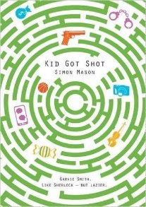
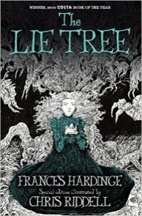
- I’ll Be Home for Christmas by Various (Author), William Grill (Illustrator) (Stripes £7.99, 15+)

