Denbighshire Creative Kids T-shirt Design Challenge - we have our winners!

15 May 2020

Earlier this month, Denbighshire Healthy Schools and Curriculum Enrichment Initiative, launched a t-shirt design competition, inviting Denbighshire’s children and young people to come up with hopeful messages and colourful images to help them overcome some of the barriers caused by social distancing and self-isolation, during the current COVID-19 restrictions.

Paula Roberts, Denbighshire Healthy Schools Co-ordinator said, “We wanted young people to still feel connected with each other in this ‘new normal’ way of life and tell us about people being strong, kind and good even in difficult times. The response has been simply amazing, with some fantastic T-shirt designs.

The judge, Catrin Hughes, Denbighshire County Council’s Internal Communications and Campaign Management Officer, said, “We have some very talented young people in Denbighshire and their designs were all brilliant. A lot of hard work, effort and design flair had gone into the T-shirts, and it was a really difficult competition to judge.”

We are very happy to announce that the three winning designers are:-

Up to 7 years
- Olivia Bloom, Year 1, Ysgol Llywelyn, Rhyl

7-11 years
- Emelia Williams, Y6, Ysgol Borthyn, Ruthin

12-14 years
- Cari Cattell, Y8, Ysgol Brynhyfryd, Ruthin

The winning designs will be printed on t-shirts.

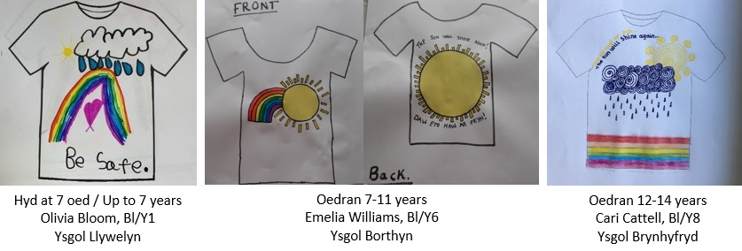

Congratulations Olivia, Emelia and Cari! Your t-shirts will be on their way to you very shortly!

Look out for the launch of the next exciting Denbighshire Creative Kids Challenges on Monday 18 May 2020 - it’s a cooking one - ‘Lockdown’ Lunch - Feed your family for a fiver!

Hopefully, there will be more creative challenges to look out for in the future during the current break from school.

