Denbighshire’s Mad Hatter’s Tea Party
‘Making Marvellous Madness’

Wouldn’t it be fun to be at a Mad Hatter’s Tea Party, just like Alice?

On Tuesday 14 May 2019, twenty-one lucky Denbighshire school children, all prize-winners in this year’s Enrichfest 2019: Wonderland schools’ competitions, have been invited, by Royal Decree of The Queen of Hearts, to an Alice Awards Ceremony and ‘Private View’ of The Cheshire Cat Gallery: Wonderland Exhibition, at Denbighshire County Council Headquarters, Wynnstay Road, Ruthin, before it opens to the public (15 May-12 July 2019). The afternoon will culminate in a very special tea party with Alice, the White Rabbit, the Mad Hatter and the Queen herself.

During the afternoon, the children will meet Alice and follow her on a magical trail around the building, as she's faced with dress design sketches, crown designs templates, riddles, magic potions, Wonderland TripAdvisor Reviews, photography displays and stage scripts. They’ll come across a speedy (and very confused) White Rabbit and the afternoon will be packed with lots of fun and adventure!

Later, the young guests will stumble upon The Mad Hatter’s Tea Party and pull up a chair around the table, feast on the Cheshire Cat’s Disappearing Sandwiches, Wacky Wonderland cupcakes, The Queen of Hearts’ Jam Tarts and sip Alice’s ‘Drink Me’ Potion.

Of course, a Mad Hatter’s Tea Party wouldn’t be complete without some tricky riddles, flying card games and ‘Musical Kings and Queens’ (a mad-cap version of Musical Chairs).

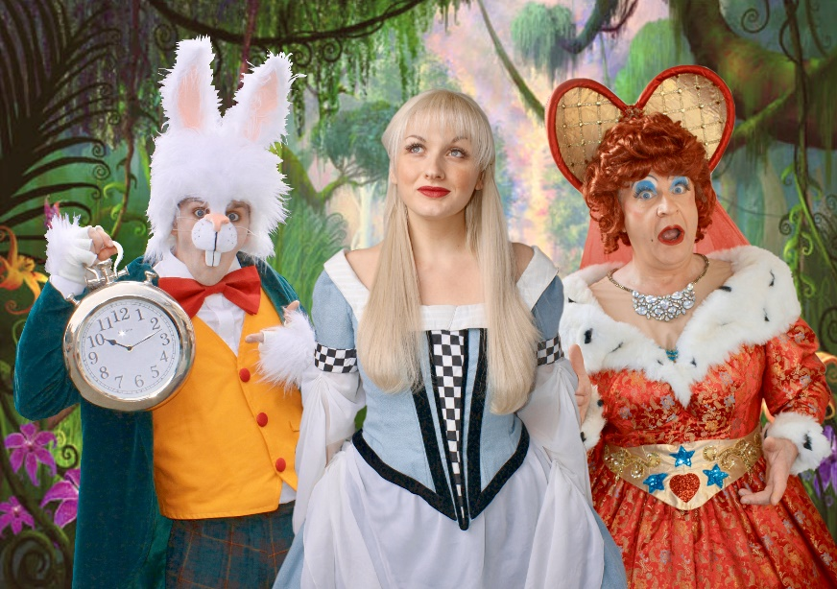
Inspired by Alice’s Adventures in Wonderland, Denbighshire Curriculum Enrichment initiative/Magic Light Productions’ ‘Mad Hatters Tea Party’ is not to be missed - so these lucky prize-winners won't be late for this very important date: Top hats and teacups at the ready...

